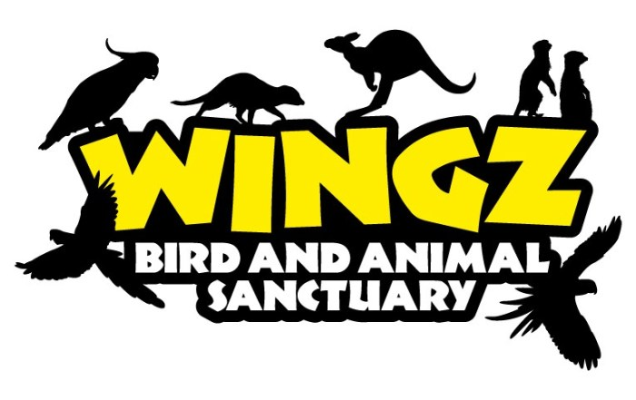

Bird & Small Animal Beauty Treatment- Terms, Conditions & Information

Dear Pet Owner,

Thank you very much for choosing Wingz for your Birds beauty treatment.

Following is an owner’s information sheet, a contract, a responsibility sheet, a care sheet and a questionnaire. I know this looks like a lot of forms, but this will ensure that your pet(s) are receiving the best care possible.

You are welcome to bring what ever you feel will make your pet’s appointment more comfortable for him/her, for example, favourite toys or treats. We have a variety of feeding and watering dishes, cages etc on hand so that you don’t have to haul everything with you.
When dropping off or picking up your pet please keep them crated on Wingz premises.

If you have any questions or concerns, please do not hesitate to email hello@wingzandthingzcornwall.co.uk

Beauty Treatment Fees
Effective January 2025
Subject to change without notice

Birds | Rate
Nails or Beak Trimming | £20.00 per treatment
Wing Clipping | To be discussed

We advise as much notice as possible to ensure the dates you require are available, especially Easter, Summer, Christmas or Bank holidays. Please note we only have so much cage space.

Drop off and pick up by appointment.

All bookings require £5 payment in advance as a deposit, non refundable on cancellation,
to sort 30-97-28 Acc 44806868, please put your birds name as reference.

Payment can be by cash or bank transfer, we do not accept cheque payments.

Owner’s Information & Booking Sheet

Name: _______________________________________

Address: _______________________________________________________________

Postal Code: ______________________

Home Number: _________________________
Work Number: _________________________
Mobile Number: ________________________

In case of Emergency please call:
___________________________ on phone number _______________________

Email Address: ___________________________________

Pet’s Name(s)
1. ____________________________

2. ____________________________

Type and Number of birds you are bringing:

___ Bird ____Other (Please State) ________________________

Registered with _______________________________Veterinary practice

Your Vets contact number ____________________________

Contract

Agreement Between
(YOUR NAME HERE) _______________________________
(Also known as the “Owner”)
and
Wingz Beauty Treatments (Grenville & Anita Allen)

It has been agreed upon between the two parties stated above that ______________________(your name here) has left in the care of Wingz the following animal(s):
1. _______________________ _________________________
(Name Of Pet and Type)
2. _______________________ _________________________
(Name Of Pet and Type)

I/We _________________________ have agreed to leave our pets listed above in the care of Wingz Bird & Animal Sanctuary for beauty treatments throughout the year of 2025 at a cost according to the current rate .

I/We agree to drop our pets off at times stated and will adhere to the conditions set out in the Responsibility Sheet, should we decide to pick our pet(s) up earlier than agreed upon or change my/our booking.

I/We agree to pay any cancellation fees as set out on the Responsibility Sheet contained in this document

I/We understand that due to certain circumstances that are beyond anyone’s control that accidents or health issues may occur, that my pet(s) may have to be taken to see a veterinarian. I/We give Wingz permission to take our pet(s) to a Vet to receive any medical attention that he/she may need. I/We also give our own Vet permission to release any information from our file on our pet’s health history should a problem arise and that the information will be useful for the care of our pet(s). I/We understand that Wingz will phone me or our emergency contact, immediately upon any reason that our pet(s) may need medical attention. I/We agree to reimburse Wingz upon picking up our pet(s) any costs of vet bills and medicine that was required in my absence.

I/We understand that this document coves nail or beak trimming & wing clipping as requested either on the booking or verbally.

I/We or any member of my family or representative hereby agrees to indemnity, agree to release from Liability; Wingz, Grenville & Anita Allen or all other related names and combination of names, for any and all risks involved with the treatments and any and all direct or indirect results thereafter. I/We or any member of my family or representative hereby agrees to indemnity, agree to hold harmless, and to release from Liability; for any claim by any person or company against Wingz, Grenville & Anita Allen and any or all other related names and combination of names, including the legal costs to defend any such claim, whether or not the damages are caused in whole or in part by the negligence, actions or inactions of any of these parties. Signing below indicates your acknowledgment, understanding and agreement to the terms contained within this Contract and Agreement, and that you are setting your hand hereto delivering your signature freely, voluntarily, and unconditionally.

Signed ___________________________ Date ____________________________
This contract will expire on December 31, 2025

Responsibility & Policy Sheet- The Owner Shall….

* Fill out a questionnaire on each pet

WE RECOMMEND THAT YOU HAVE PET INSURANCE IN PLACE FOR YOUR PET AS WE DO NOT HAVE INSURANCE TO COVER SHOULD YOUR PET HAVE A MEDICAL EPISODE WHILE IN OUR CARE.

* Provide ALL health-related information no matter how small of an issue it may seem

* Will call or email if they will be coming later than agreed upon to pick up or drop off their pets- (please remember we don’t just have your pet to care for), and understand there could be a late charge for pick up’s outside of agreed times.

* Will pay the amount due for services when they pick up their pets unless other terms and conditions are in place.

* Will reimburse any vet bills that were incurred due to normal health problems or accidental injury

* Will keep our pet crated when dropping off or picking them up

* Will pay a non refundable £5 deposit on booking

* You can email Wingz any time at hello@wingzandthingzcornwall.co.uk, or contact us via facebook.

* Bookings & Cancellation

* All bookings require a £5 payment in advance as a deposit, non refundable on cancellation,
to sort 30-97-28 Acc 44806868, please put your birds name as reference

* Pick Up and Drop Off Times by appointment

This sheet is valid for the year 2025

________________________________ _______________________
(Owner) (Date)

General & Elderly Pet Veterinarian/Post Mortem Care Form

Please be as detailed as possible when listing your wishes regarding your pet in the event that an immediate decision must be made about care if I am unable to reach you by phone.

Owners Name: ___________________________________________
Pet’s Name(s): ___________________________________________

We will having bird beauty treatments for our pets throughout the year of 2025.
During this time, I/We ___________________________give Grenville & Anita Allen of Wingz Bird & Animal Sanctuary Boarding consent to participate in our pet(s) veterinarian care up to a max £_______________ for each pet listed above.

Should my veterinarian deem it necessary that my pet’s condition is going to require long term and on going care I request that: (Please check all that apply regarding long term or potentially fatal circumstances where treatment may be redundant ie: how far do you want us to go?!) Use the back of this sheet for more space:

 At Veterinarian’s discretion
 Quality of life over quantity of life
 By all means save my pet’s life
 No heroic measures please euthanize
 No long term or ongoing care results please euthanize
 Please keep pet alive if possible until my return or I am reachable

I give Grenville & Anita Allen consent to allow the following procedures as recommended by the Veterinarian: (Please check all that apply)
 Blood work
 Urinalysis
 X-rays
 Minor Injuries
 Major Injuries
 Faecal testing
 Prescription renewals
 Surgical procedures
 Blood Transfusions
 At Veterinarian or kennel owner’s discretion

I release Grenville & Anita Allen and/or Wingz Bird & Animal Sanctuary Boarding from any claim, should my pet pass away during the time that it is staying in their care. Should a death occur due to old age, natural causes, or accidental causes I wish:
 For the remains of my pet to be taken to the veterinarian clinic for cremation and I understand I will be responsible for any fees for the service of cremation. Tick choice:- Ashes to be kept for owner _____ Vet to deal with ashes_____
 For the remains of my pet to be taken to the veterinarian clinic for disposal.
 For the remains to be stored until my return. Please note over two days the animal will need to be frozen.

I understand that I am still responsible for boarding fees up until the time of the death of my pet and any veterinarian related fees associated with disposal or cremation.
 I wish to be notified immediately or as soon as possible
 I wish to be notified upon my return.

__________________________________ _________________________
(Owner) (Date)

Questionnaire

Name of Pet: __________________________

Breed of Pet: _____________________ M/F? ________

Age: _________ D/O/B (If Known) _____________

Please list any current health problems or concerns you may have with your pet:
_______________________________________________________________________________________________________________________________________________________________________________________________________________________.

Is your pet on any medication or is having at home vet care? If so please list medications and instructions for care:

Does your pet have food allergies or any snacks or foods he/she is NOT allow to have?

_______________________________________________________________________

What is your pets favourite: Treat: _________________Toy: ______________________

My Pet :
___Likes affection whenever it’s given
___Likes affection on his/her terms
___Is ok with nail trimming
___Likes to play with toys
___Likes to spend some time outside his/her cage
___Is afraid of thunder
___Is unsure of strangers
___Likes the radio playing
___Uses bad language
If there is anything else you could like us to know about your pet please use the space below. Please also include your pet’s daily routine and schedule.
______________________________________________________________________________________________________________________________________________________________________________________________________________________________________________________________________________
__________________________________________________________________________________________

Wingz Bird & Animal Sanctuary Boarding
Lowarth An Ydhyn, Treesmill, Par PL24 2TX

hello@wingzandthingzcornwall.co.uk Facebook:- Wingz & Thingz or Wingz K9 Secure Paddock

